Quick Wins:
News Reporting:
For news-related content, prioritize speed and relevance over perfection. Ensure it aligns with your channel's long-term goals.
Pros: Can bring a significant spike in views quickly, attract new viewers, and with an effective end screen strategy you can funnel them through your content to create mega fans and get more views on older videos too.
Cons: Videos quickly become outdated; they might flatline after the news is no longer fresh.
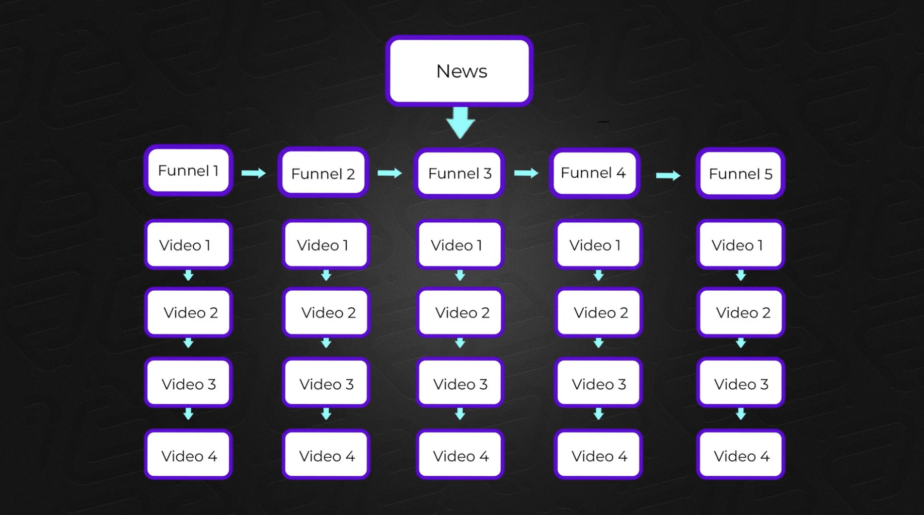
Jumping On Trends:
Keep an eye on relevant news or trends within your niche. Use tools like Google Trends to spot high-demand topics.
Plan content that aligns with seasonal interests or events to capture timely viewer interest.
Pros: Can capture seasonal interest or ride the wave of emerging trends for easier views and very fast growth.
Cons: Risk alienating your core audience if the trend is too broad or unrelated to your usual content.
Collaboration:
Find collaborations that enhance your credibility and reach. Choose partners who are consistent and whose audience aligns with your niche.
Pros: Attracts new viewers through association with other channels, raises your credibility, and requires minimal additional work if leveraging existing content.
Cons: May not always reach publication; effectiveness depends on the collaborator's audience engagement and consistency.
Evergreen Content:
Pros: Continues to attract views over time, can be revitalized with new thumbnails or updates, lays the groundwork for exponential growth.
Cons: Requires thoughtful planning and may not provide immediate gratification in terms of view count spikes.
Instructions for Implementing Strategies:
Identify Trends or News:
Keep an eye on relevant news or trends within your niche. Use tools like Google Trends to spot high-demand topics.
Create Content Quickly for News/Trends:
For news-related content, prioritize speed and relevance over perfection. Ensure it aligns with your channel's long-term goals.
Leverage Seasonality:
Plan content that aligns with seasonal interests or events to capture timely viewer interest.

